Using these photographs and information can you piece together Hans’ and Sophie’s stories?
Do you think their actions show them to be supporters or critics of Nazism?
Explain your opinion with examples.

Sophie Scholl reading in about 1933 https://bit.ly/3AlElsi

Sophie Scholl joined the League of German Maidens in 1933, despite the opposition of her father, Robert who was a pacifist and anti-Nazi. Elisabeth, Sophie’s sister, later recalled their father’s reaction to Sophie and her involvement in the Hitler Youth. “We dismissed it, he’s too old for this…we were all excited in the Hitler youth in Ulm, sometimes even with the Nazi leadership.”
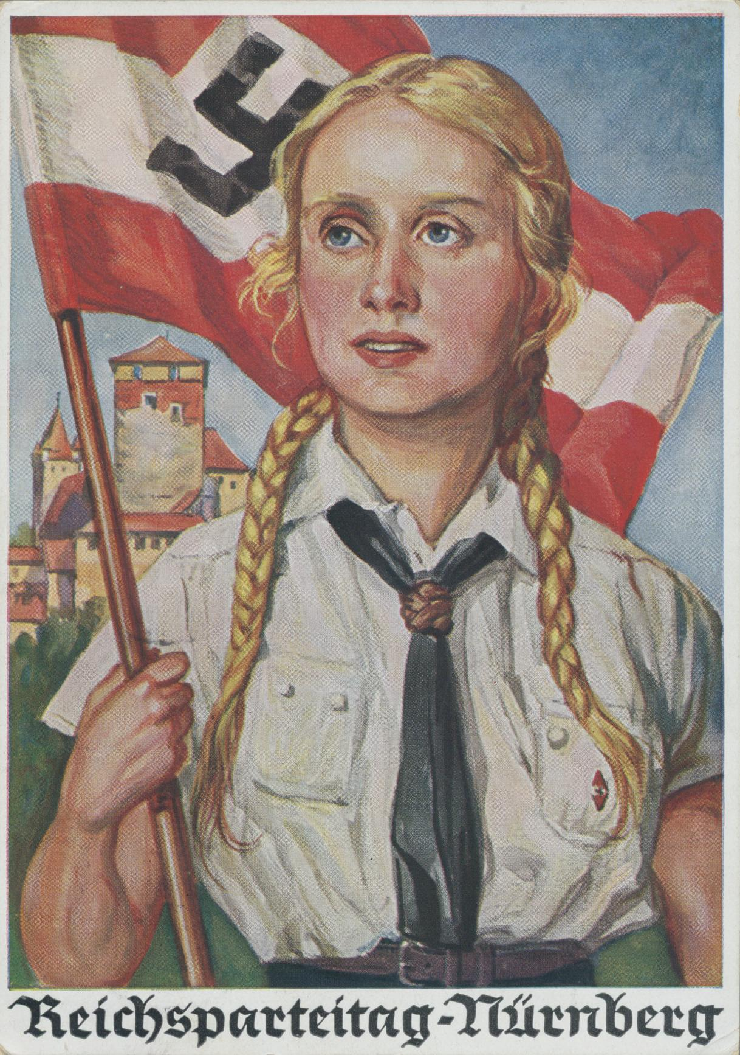

Image: Unaccredited illustrator (anonymous artist), CC BY-SA 4.0 <https://creativecommons.org/licenses/by-sa/4.0>, via Wikimedia Commons
https://bit.ly/3hbbHTy
The poster is aimed at its members who were aged 10-14. Sophie was born in 1921. Perhaps, in the photograph, she is reading one of her favourite authors, the left-wing Jewish writer, Heinrich Heine. She remarked on one occasion: “whoever does not know Heine, does not know German literature”.

On a cycle tour with members of the BDM (League of German Maidens) that included her sister Inge in 1936, Sophie gave her opinion on the Nazi policies following the Jewish people under the Nuremberg Laws. Later, her sister, Inge recalled what Sophie had said: “Everything would be fine, but this thing about the Jews is something I just can’t swallow”.

Hans Scholl joined the Hitler Youth in 1933. He became leader of his local Hitler Youth group. He went on numerous Hitler Youth camps, where young people learnt to march, hike, traditional folk songs and had lessons in the idea of the Master race and hatred towards other races including anti-Semitism.

Hans at Nazi youth camp 1937 – available here: https://spartacus-educational.com/GERschollH.htm

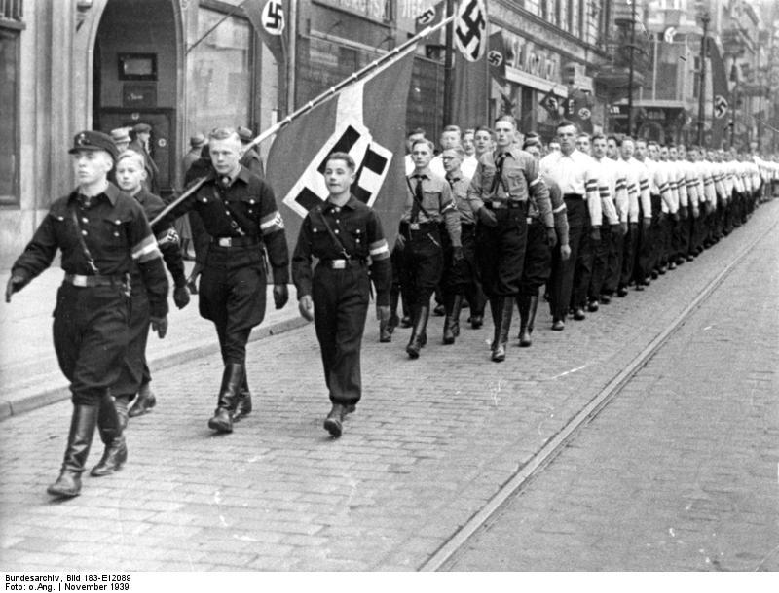
Image: Bundesarchiv, Bild 183-E12089 / CC-BY-SA 3.0, CC BY-SA 3.0 DE <https://creativecommons.org/licenses/by-sa/3.0/de/deed.en>, via Wikimedia Commons
https://commons.wikimedia.org/wiki/File:Bundesarchiv_Bild_183-E12089,_Posen,_Amtseinf%C3%BChrung_Arthur_Greiser.jpg

In 1936 Hans was a flag bearer at the Nuremberg Rally. This was an annual staged event where Hitler spoke (eventually) to the whole nation with Nazi party officials, young people and German soldiers in attendance. His sister Inge said of her brother when he came back from the Nuremberg Rally: “His joy was great. But when he returned we could not believe our eyes. He looked tired and showed signs of great disappointment…the leaders told him his songs were not allowed…merely because they had been created by other races.”

In 1937, Hans Scholl volunteered for the German army. He joined the cavalry unit and would have worn the grey uniform of the Wehrmacht (German army) around the streets of Munich. After 6 months of army service in 1937 Hans was arrested by the Gestapo and held for about a month. They searched the family home for anti-Nazi materials such as songs, pamphlets etc. His commanding officer intervened and spoke of Hans as being a “good and loyal soldier”. He was released and later promoted to sergeant.

In 1937 the Gestapo arrested Sophie, when they were concerned about her brother’s un-Nazi activities. She was released the same day and returned to the family home. It was another step towards her dislike of the very strict (authoritarian) regime of the Nazis. One historian commenting on this event in Sophie’s life stated: “She seemed too young, too girlish to be a menace to the (Nazi) state”.
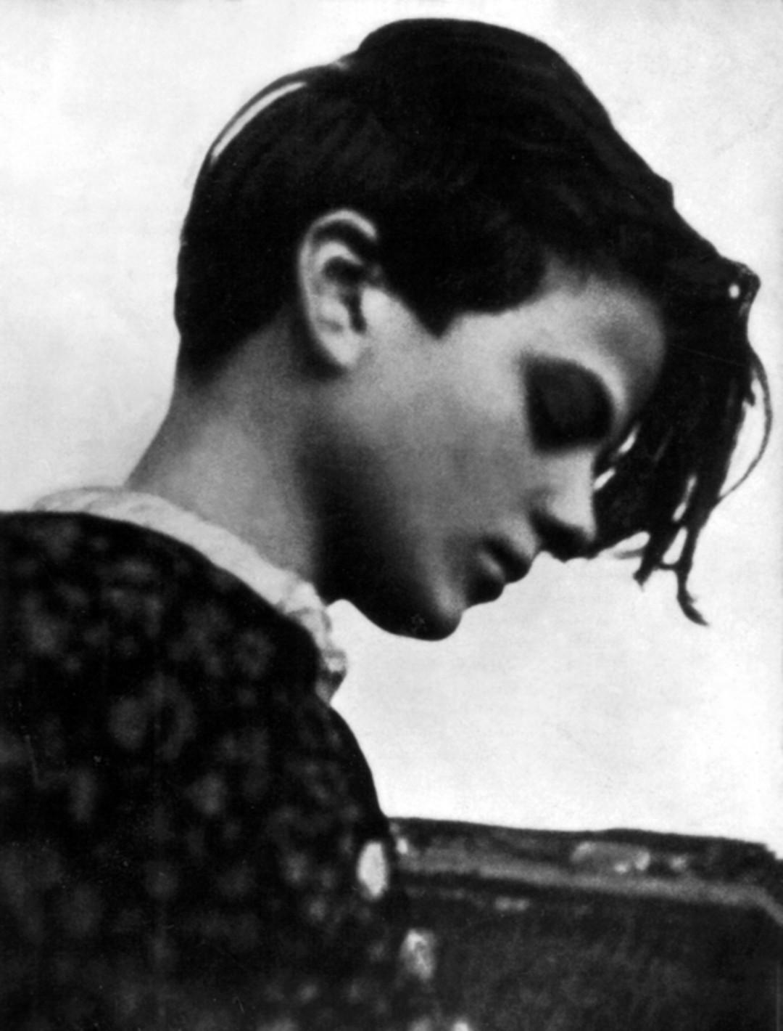
1939: https://commons.wikimedia.org/wiki/File:Sophie_Scholl_in_Blumberg_1942.jpg#filelinks

Hans, like millions of other young Germans aged 19 was put to work for 6 months as part of the German Labour Service. His task was to help build the German autobahn (motorway). He did so near the town of Goppingen in 1937.

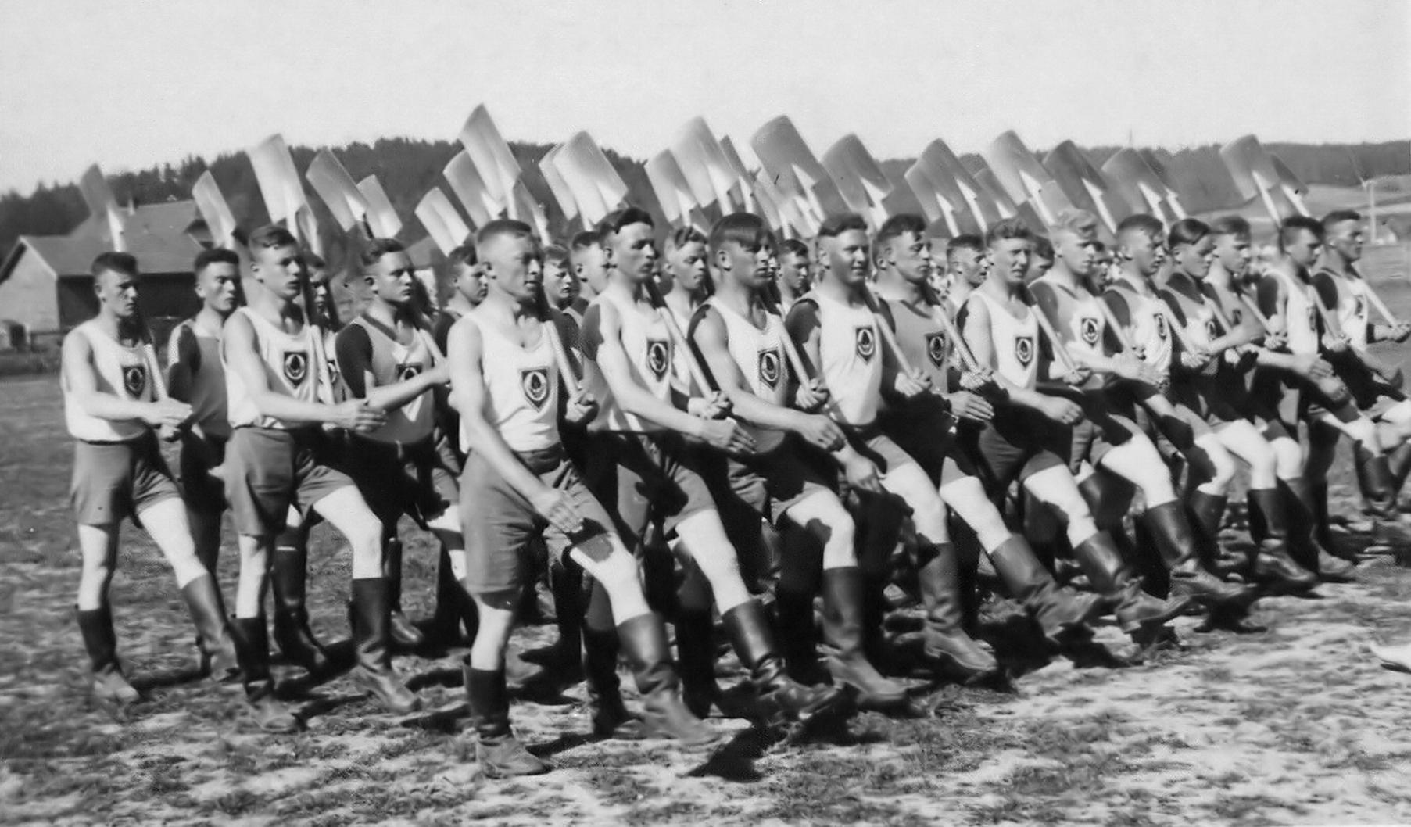
Image: 1937 national service: Father of de:user:Philipendula. Philipendula has herited the rights on this image., CC BY-SA 3.0 <http://creativecommons.org/licenses/by-sa/3.0/>, via Wikimedia Commons
https://commons.wikimedia.org/wiki/File:Arbeitsdienst.jpg

At the age of 19, young people were conscripted to work for the German state on some activity of public works as part of the German Labour Service

In 1939, Sophie had a difficult final year at school. She was called into the principal’s (head teacher’s) office on several occasions and warned that her opinions might lead to her being refused the opportunity of sitting her final year exams for a university place. Also, Sophie expressed her opinions to her boyfriend, Fritz about to serve in the German army, on what entry into the Second World War might mean for the people of Europe.

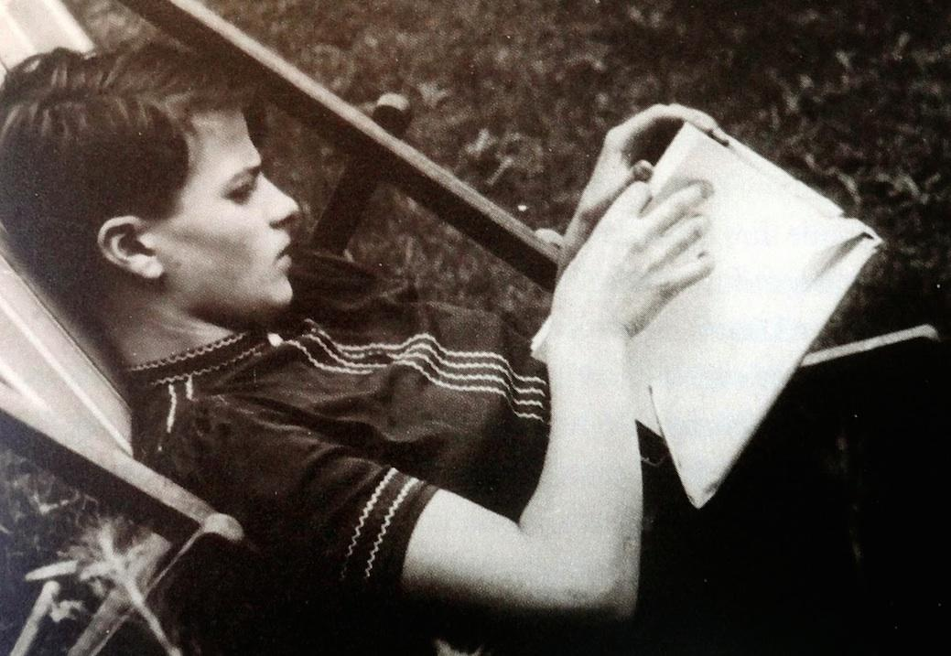

“I can’t grasp that now human beings will constantly be put into mortal danger by other human beings.”

In 1940, Sophie became a kindergarten teacher in her hometown of Ulm. A year later, she had to move and do 6 months for her National Labour Service as a nursery teacher in the town of Blumberg.

Image: https://www.flickr.com/photos/farinihouseoflove/5494826007

BDM take babies to the park. The Nazis promoted their ideal for a German woman as “Kinder, KÛche und Kirche” – “Children, Kitchen and Church”.

After 6 months of working for the new German Labour Front, Hans went to medical school at Munich University. In between studies Hans was sent to France in 1940, as part of the medical corps. Here, as a trainee doctor, Hans helped soldiers who had suffered amputations.

Image: Hans Scholl (second from left)– last meal with fellow soldiers together, before being deployed to different areas of the Russian front: https://bit.ly/3jFBN2i

Sophie had a boyfriend, Fritz Hartnagel. He was a loyal supporter of Adolf Hitler and joined the German army. Fritz and Sophie regularly wrote letters to each other in the years 1941-1943.

By 1941, Fritz was fighting the Russians on the Eastern Front. He saw the mass killing of Russian prisoners-of-war and civilians including the targeting of Jewish people, by German forces as they fought to take control of the Soviet (Russian) city of Stalingrad in 1942-3.

Photo of Fritz Hartnagel - https://spartacuseducational.com/Fritz_Hartnagel.htm

In 1941, Sophie was able to enrol at the University of Munich to study biology and philosophy. She also had the chance to go hiking, swimming and skiing.

Photo of Sophie swimming available here: https://www.newsletter.co.uk/news/german-students-courage-oppose-hitler-paid-their-lives-1046118

A year later Sophie with other members of “White Rose” wrote the following about the treatment of Jewish people:

“Since the conquest of Poland, 300,000 Jews have been murdered in…the most bestial crime against human dignity, a crime unparalleled in the whole of history. For Jews are humans too…” White Rose, Second leaflet, June 1942.

In July 1942, Hans was sent to the Eastern front. In his diary and letters home he wrote in despair about the mass killings of Jewish and Polish citizens by soldiers of the German army.

Hans described to his sister Inge, how his troop-train stopped at a Polish station, on its way to Russia. At the trackside he saw women and girls bent over doing heavy work with pick axes. They wore the yellow Start of David on their blouses. He alighted and slipped into the pocket of an emaciated girl, a flower and his “Iron Ration” box (of chocolate, raisins and nuts). She threw the box onto the ground at his feet with a harassed but proud gaze on her face. Hans picked it up and smiling stated: “I just wanted to do something to please you.” The train started to move off, so Hans, in a few bounds, leapt back on board. From the window, he could see the girl standing still, with the white flower in her hair.

In June 1942, Hans Scholl with close and like-minded friends from Munich University (plus his sisters) set up a group called “The White Rose”. Sophie’s boyfriend, Fritz donated 1,000 Reich marks for the group to buy a printing press and materials to publish and distribute copies of 6 leaflets to others.

In July 1942 Hans and Sophie expressed their approach to fighting against the Nazi state: “The meaning and goal of passive resistance is to topple National Socialism” (White Rose, Third leaflet, July 1942).
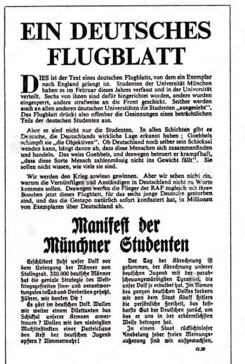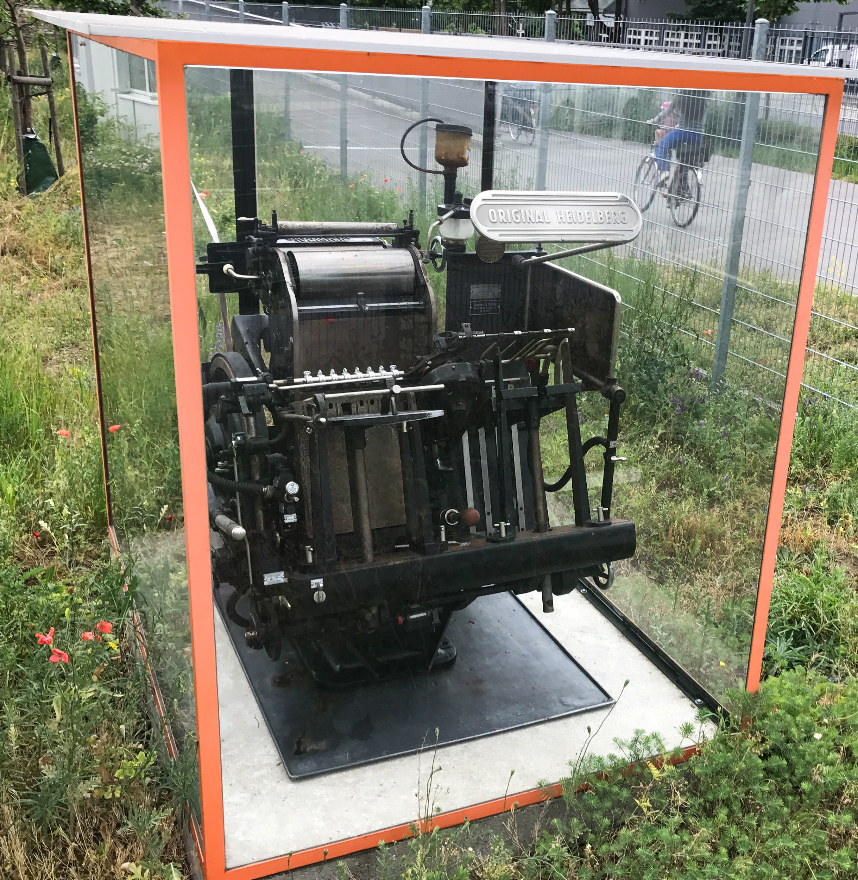
Image: Original Heidelberg printing press, Thomas Quine, June 5, 2017

In February 1943, Hans, Sophie and Christoph Probst were picked up by the Gestapo, following a tip-off, with a 7th handwritten leaflet in Hans’ pocket. In total, the White Rose sent about 15,000 envelopes named and addressed, all around Munich University and to other towns such as Stuttgart and Berlin. Many of the receivers handed in the unsolicited (they had no prior knowledge or had not asked for the letters) leaflets because they were fearful of being arrested by the Gestapo (secret police) and accused of supporting the key aims (manifesto) of the White Rose group.

“Such a fine, sunny day and I want to go but what does my death matter…if through us, thousands of people are awakened and stirred into action.”

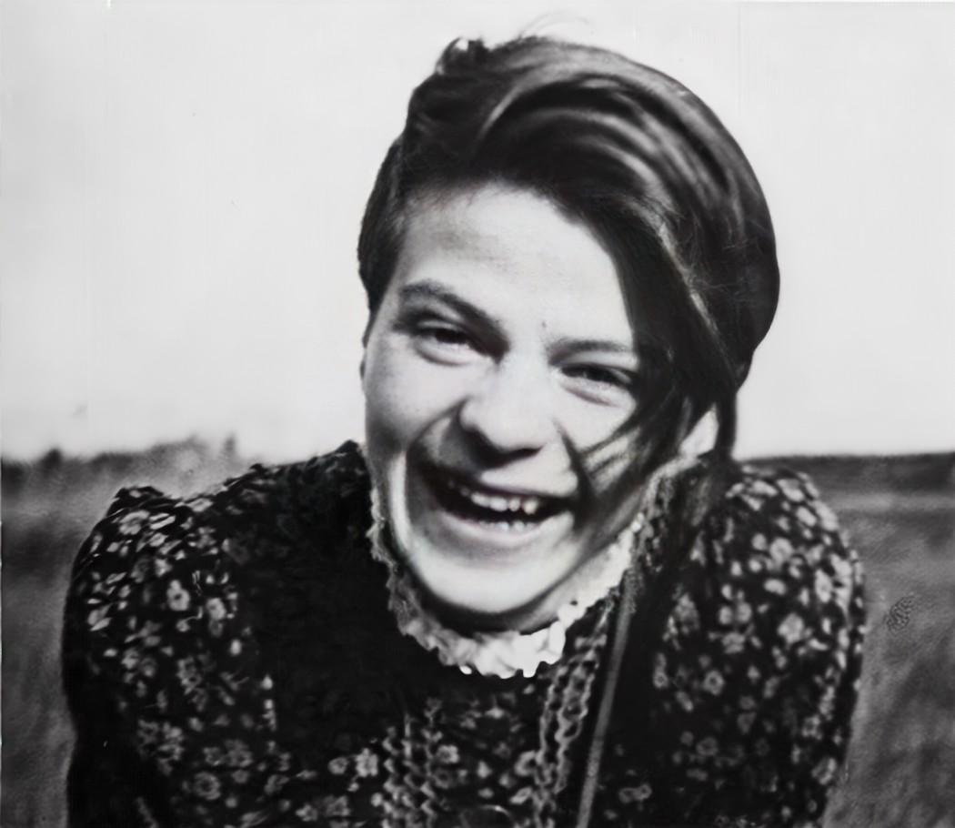
Unknown author, Public domain, via Wikimedia Commons
https://commons.wikimedia.org/wiki/File:Sophie_Scholl_1938_in_Blumberg_(restored).jpg

Sophie Scholl
9th May 1921 Forchtenberg, Germany – 21st February, 1943 Stadelheim Prison, Munich, Germany

